

**REQUIREMENT ANALYSIS & USABILITY**

**REPORT**

**<Project Title>**

**Home Automation System**

**<submitted by>**

Group Number # 32

**<Client>**

Dr. Mansoor Ebrahim

**<Submitted to>**

Dr. Mansoor Ebrahim

**<GitHub Repository Link>**

https://github.com/Muhammad-Rujail-hamza-Shaikh/IOT-BASED-HOME-AUTOMATION-SYSTEM.git

* **USE CASE DIAGRAM:**







|  |  |  |
| --- | --- | --- |
| **Use Case Name:** | Home Automation System | |
| **Actors Involved:** | User. Adafruit, Controller | |
| **Brief Description** | Different types of interfaces and functions that contains the features and working of the software and hardware. It will help the customers to know about the particular features and various attributes of the home automation | |
| **Normal Flow of Events:** | **Actor Action** | **System Response** |
| 1. Give commands. | 1. System will perform the given task. |

* **DATA FLOW DIAGRAM:**





# UI DESIGN:

User interface design (UI) or user interface engineering is the design of user interfaces for machines and software, such as computers, home appliances, mobile devices, and other electronic devices, with the focus on maximizing usability and the user experience.

**1-**In this project we have use Adafuit to control home appliances by Web Server.

**2-**Also uses google assistant to pass commands through voice notes.

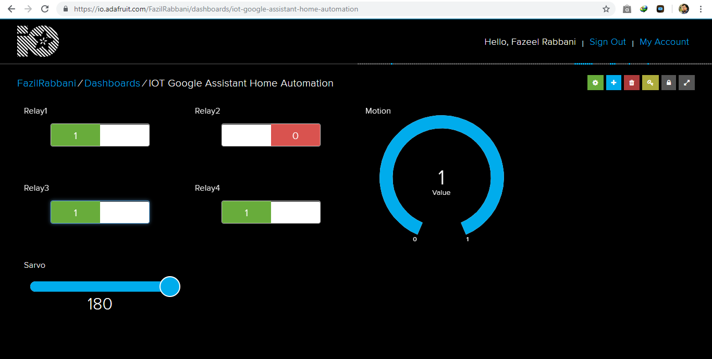**WEB SERVER (IO-ADAFRUIT):**

**IFTTT ( IF THIS THEN THAT) INTERFACE BY ADAFRUIT:**

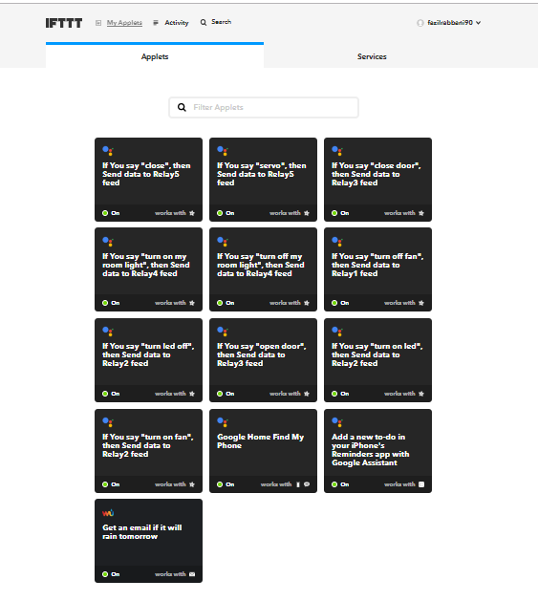

**GOOGLE ASSISTANT:**

